Name: Delanoë & Ragon Grp : 131

Firstname: Germain & Matéis

Name of the laboratory work: Measuring g with a magnetic pendulum and smartphone magnetometer

Goal of the experiment: Measure *g* using several methods.  
Describe the interest of conducting this experiment: To find the acceleration due to gravity (*g*) experimentally.

What information can the experiment help understand?  
The relationship between the period of the pendulum and the length of its string.

Why is this experiment necessary?  
This experiment is necessary because it allows us to estimate the value of Earth's gravitational constant.

Physics of the studied experiment:  
What is the physics (phenomenon or physical properties) involved in this experiment?  
It is the phenomenon of gravitation.  
How is this phenomenon involved?  
Before being released, the pendulum has gravitational potential energy. Once released, it is attracted toward the ground due to the gravitational force. Thanks to the pendulum's motion, which converts Earth's gravitational force (which is invisible) into periodic motion (visible to the naked eye), we can then calculate the gravitational constant.

Equipement:

Mettre une photo et décrire tous les appareils qui sont utilisés dans cette expérience.

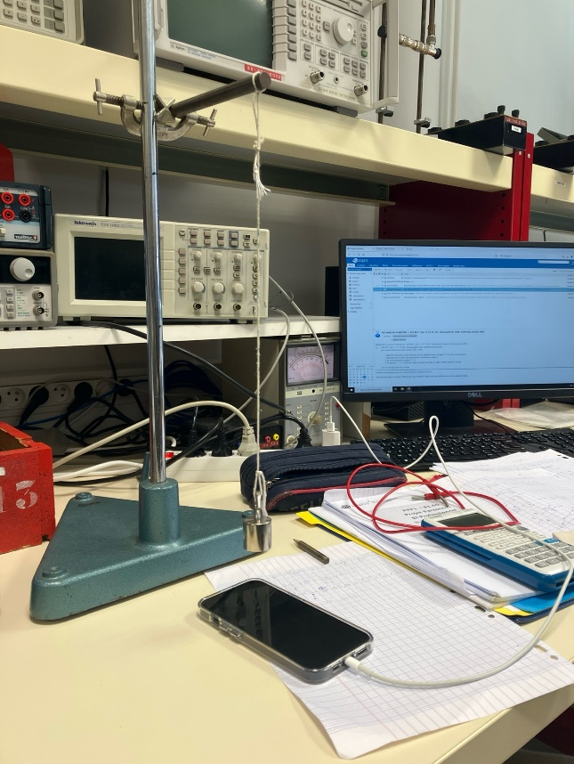

In this experiment, we use a magnet suspended by a string. We measure the variations in the magnetic field caused by the movement of the magnet using our phone. We also measure the time it takes for the phone to fall when we release it, using the same phone.

Experimental Results:

Donner tous les résultats.

Ne pas mettre de tableaux mais des **graphiques.**

**Tous les résultats doivent être donnés avec son incertitude.**

**Comparer les résultats à la théorie.**

**Décrire les résultats en fonction du phénomène recherché**

Expliquer avant toute présentation de résultats ce que vous avez cherché à mesurer.

Donner une explication si ça ne correspond pas aux résultats prévus.

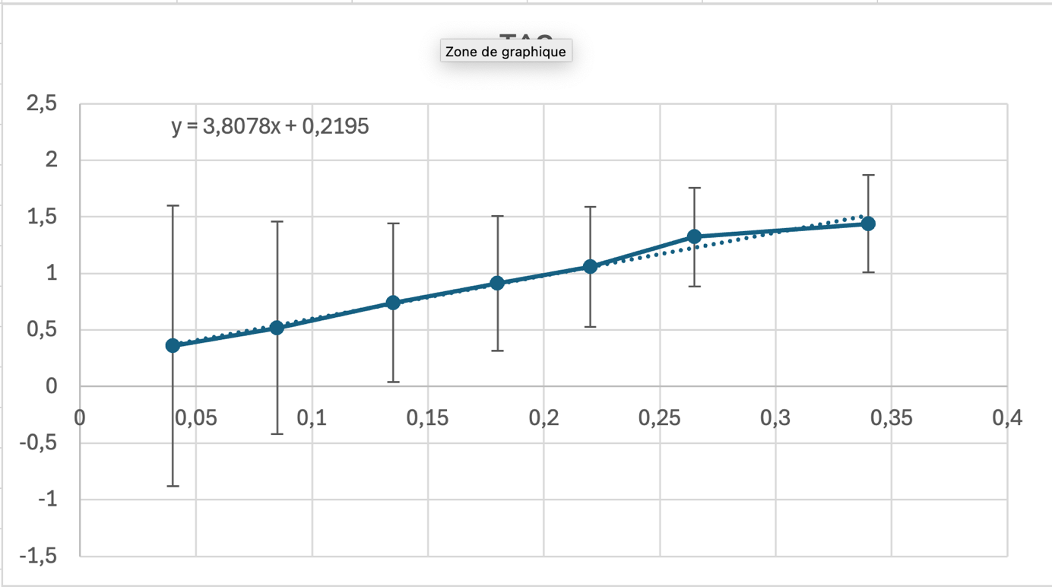

Using our results, we observed that *g* was approximately equal to 10.5 N·m², which is not very precise since we know that *g* is equal to 9.81 N·m².

Conclusion:

Conclure sur les résultats observés. En quoi l’expérience a permis de comprendre un phénomène physique.

The experiment allowed us to observe the relationship between the motion of the magnet and the variations in the magnetic field, which were detected by the phone. By measuring the fall time of the phone, we were able to indirectly assess the effects of gravity on the phone's motion. This experiment demonstrated how gravitational forces influence the movement of objects and how this can be measured experimentally. It helped us better understand the principles of gravitation and the connection between motion, time, and gravitational acceleration